White water on the River Nile
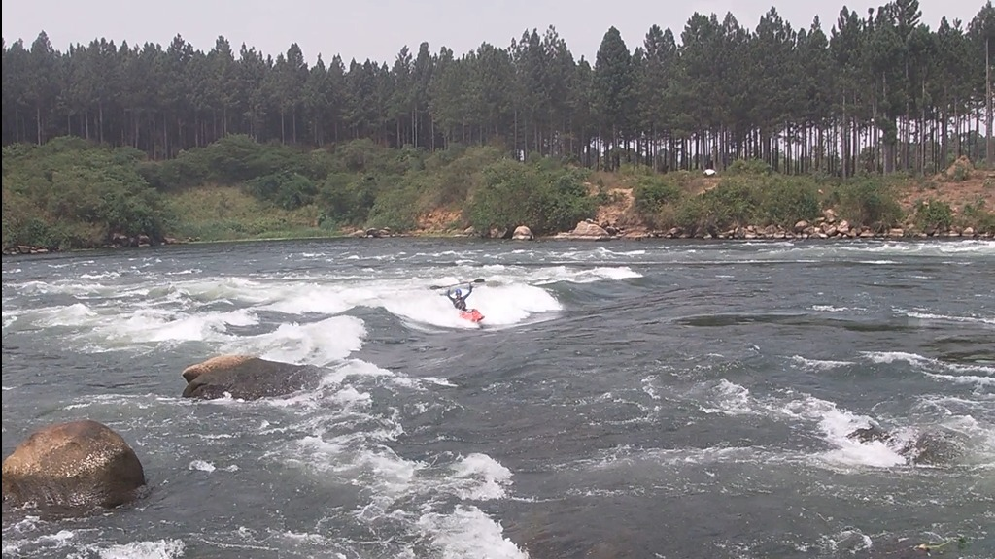
Karson Segner kayaking down class III rapids on the River Nile outside of Jinja, Uganda.

A boy and the river

Along the banks of the River Nile a few miles outside of Jinja, Uganda a hidden oasis of white-water rapids serves as an adrenaline junky’s playground for kayakers from all over the world.

An adventure seeker himself, 17-year-old, Karson Segner, has spent most of his teenage life kayaking between the banks of the river.

While Segner is a native Texan born in College Station, TX, his family moved to Uganda when he was only seven years old.

His kayaking career started with a couple lessons from a neighbor upstream in pursuit of a new pastime. Little did anyone know, just a few months later he would be tackling rapids professionals travel across the world to attempt.

White-water rapids and their intensity are distinguished through a class ranking with I being the tamest and VI being the most treacherous.

Just a short swim down the river from his house, are a series of rapids beginning at class III for Segner to test his kayaking limits.

The original fear of plummeting down the rapids may have subdued, but Segner said there will always be an “oh my gosh, what am I doing?” feeling as his kayak tips into the rushing waves.

This level of kayaking is an intense sport. It takes a great deal of courage and nearly every ounce of strength a kayaker has to fight the water attempting to overtake the boat.

“After a day on the white rapids, I always walk away thinking I am never kayaking again because of how sore I am,” Segner said.

According to Segner, kayaking success is all about knowing where the rocks are. The best way to approach a new section of the river is by following someone who has kayaked the route before you, using them as a scout. Then follow their motions and do whatever is possible to avoid crashing into a boulder.

“If your kayak manages to flip, the best thing to do is swim out of your kayak to shore, hold your paddle, and hope someone catches your boat,” Segner said.

Segner’s parents say he averages two to three hours a day on the river practicing new tricks and flips. When he is not in a boat, Segner is usually analyzing kayaking tricks from his favorite Youtuber, Dane Jackson.

“I like the challenge of learning cooler tricks and tackling bigger rapids,” Segner said. “It is also a great way to be outside and enjoy some alone time.”

Community of paddlers

Some of Segner’s more memorable kayaking adventures though, have not been by himself. He and his friends, Paytyn Ostermann and Elijah Fish, have begun to test their luck with this sport as well.

Segner’s mother says once these three get out on the water together they are nearly impossible to call back in for supper.

In June of 2021, Segner and his friends were out on the river when a kayaker they had never seen before paddled by taking their set of rapids faster than they had ever seen. Intrigued by who this foreign professional was, they raced down the water to catch up.

These three teenagers were about to meet one of the top 10 kayakers in the world on a quick visit from Argentina. By the end of the day, they had travelled farther up and down the Nile than any of them had ever attempted and received a first-class lesson from their new kayaking friend.

“The adventure of kayaking goes farther than the rocks and your paddles,” Ostermann said. “It is a community of kayakers all looking to add a little more fun into their days.”

The Nile River festival
Segner and his friends recently attended the Nile River Festival, a kayaking competition which historically has drawn competitors from across the globe. This year, kayakers even came all the way from Russia to attend.

The competition is a three-day long event for anyone with a boat and enough money to cover the small entrance fee.

Do not be fooled though, this competition is anything but traditional. Events include the Superholympics where paddlers ditch their boats to test their luck down rapids riding an inflatable pool float. Another fan favorite is the Big Air Ramp, which sends competitors flying into the air before slapping against the water.

“If you mess up on the ramp you hit the water hard,” Segner said. “But I think with a little practice, I may try it someday.”

After three days of kayaking extravagance, the competition ends with a wildly eccentric party in celebration of love, the land, and the joy of kayaking.

When asked where he sees kayaking taking him later in life, Segner said he hopes to someday travel around the world and tackle other people’s version of their Ugandan Nile oasis.

